Meet the FST Guild Committee | 2021-2022

Tyreke McLean
President, FSTGC

Message

Zeniquea A. Powell
Vice President, Services and Special Projects, FSTGC

My portfolio allows me to reach out to people under various projects and I intend on spreading kindness and support through these acts. Moving into the new school year there will be challenges, there will be days where we will have to balance lab submissions and guild meetings. However, having such strong support from my president and fellow guild peers, I also look forward to a successful school year, one with many accomplishments and victories. To the Faculty of Science and Technology, I say THANK YOU and I wish you all good health and strength for the years to come.

Roy Robinson
Vice President, Properties and Specials Initiatives, FSTGC

I plan to execute my portfolio to the best of my ability, improving the number of opportunities in sponsorship and internship while providing services to my faculty.

Delano Mullings
Treasurer, FSTGC

"No problem can be solved from the same level of consciousness that created it" ~ Albert Einstein.
About me, Goals for tenure and Message to the faculty:
I am Delano Mullings, a person very determined, hardworking, and dedicated. A firm believer in constant growth and personal development. I must say it is a privilege for me to be given the opportunity to serve as a member of the 2021-2022 FST Committee. I intend to put my problem-solving skills to work to make a positive impact within the faculty; seeking to find meaningful financial solutions to our problems. To the members of the faculty, I want to wish you all a very productive academic year. Nothing great in life comes easy. We are all faced with our own adversities, but remember, "in the middle of every difficulty lies opportunity" ~ Albert Einstein.

Andre Gordon
Assistant Treasurer, FSTGC

I am currently a second-year student at The UWI. I am majoring in Mathematics with Education. I am a past student and former Head Boy at Excelsior High School. I am a Christian and a member of the March Pen Church of the Nazarene. I mostly enjoy listening to music. I aspire to be a leader that others can look on and be inspired. I also love to volunteer and help others. It is really an awesome opportunity to serve my faculty. What I hope to achieve during this tenure is personal and professional growth and to inspire other students at the UWI to get involve, volunteer and be a role model.

Shanelle Bramwell
Secretary, FSTGC

Message: For the 2021-2022 academic year, I strive to actively contribute to all aspects of student development and that of the Faculty of Science and Technology. My main aim is to ensure full execution and a seamless experience this academic year. My favourite quote is ‘‘It’s better to waste a minute of your life than to lose your life in a minute.”

Keneisha Henry
Assistant Secretary, FSTGC
In my tenure I hope to actively contribute to holistic development of students within the Faculty of Science and Technology as the FSTGC strives to greater meet the needs of our peers. My favourite quote is, “In all you do, pray, prepare & execute excellently” and that is exactly what I plan to do with my cohort in the academic year 2021/2022.

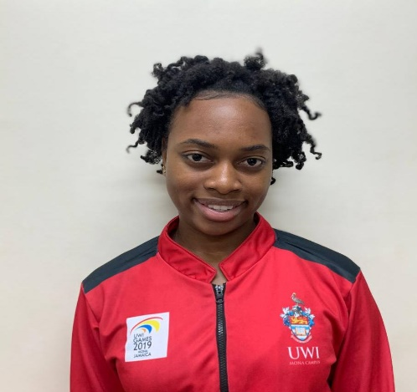
Xanice Johnson
Chairperson, Games Committee (Female), FSTGC

“An indiscipline mind is the greatest set back, so regroup and open your mind to the infinite possibilities this world has to offer”. I am deemed as a social butterfly, vibrant, determined and interactive in every aspect. I am elated to be serving as the Games Committee Chairperson as this provides me with the platform to network and engage with students and staff on a personal level. In my tenure I intend to create a bond with individuals, implementing innovative measures and creating a safe space for all while surviving this pandemic. The Games Committee is here to support everyone physically and mentally as we have a variety of events planned for all. I look forward to contributing to the faculty of greatness and in serving you.

Ronaldo Hayle
Chairperson, Games Committee (Male), FSTGC

It is truly a pleasure to serve as the male Games Committee Chairperson as it aligns tremendously with the individual I am. I am jovial, athletic, multi-talented and always willing to learn and try new things. My daily mantra is, “If you want something you have never had, you must be willing to do something you have never done,” quoted from Thomas Jefferson. My portfolio is not just about games, there is an optimum level of planning, evaluation and execution. We’re told, “Read for our degrees,” and “No play and all work makes Jack a dull boy.” However, the Guild Games Committee is here to show you that we can excel at both. University life is not confined to just academics, there is a myriad of activities and events waiting for you! With all that being said, laugh more, lyme more and vibe more.

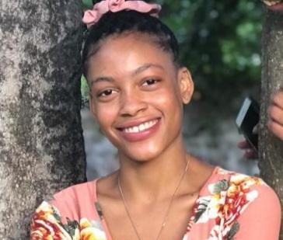
Ronika Haughton
Public Relations Officer, FSTGC

"It always seems impossible until it's done" Life...what is life all about? Life has some much to offer, it's all about new experiences, learning, and finding yourself. Of course there's going to be ups and downs, but we shouldn't let the downs get to us, shake it off and try again. Failures are just another learning opportunity. And never be afraid to try new things, "you can't knock it until you try it". And lastly, we’re all in this together, we've got this.

Romahno Williams
Chairperson, Cultural Entertainment Affairs, FSTGC

I am a very vibrant person who tries to bring light to anywhere I go and I do my best to be the "Life of the party". I enjoy interacting with my peers and ensuring everyone is comfortable and having a good time. With this position, I intend to apply the same attributes. University is the place to network and market yourself. Planning social events and forums will definitely be an icebreaker for people to step out of their shell and do so. As well as to get the different cultures to learn about each other and develop a better understanding. This is what I'm all about: integration, networking and making everyone comfortable. My tenure promises to be an epic one, stay tuned.

Aaliyah Campbell
Deputy Chairperson, Cultural Entertainment Affairs, FSTGC

I hope to put my best skills to use and liven up the university experience for students through creativity and positivity during my tenure. I want others to know that they too can make a change by taking a chance and stepping out of their comfort zone and making the most of their time whether applying for a position or joining a club. “Start where are you are. Use what you have. Do what you can.”- Arthur Ashe, and “However difficult life may seem, there’s always something you can do and succeed at.” - Stephen Hawking

Chanice Henriques
Chairperson, External Affairs, FSTGC

“The heights by great men reached and kept were not attained by sudden flight, but they, while their companions slept, were toiling upward in the night." - Henry Wadsworth Longfellow
In order for us to achieve our aspirations in life, we must dedicate ourselves to the cause. The aim however, is not to overwork oneself, for adequate rest and proper health practices are the keys to success.

Jaun-Luc Brown
Deputy Chairperson, External Affairs, FSTGC

Life is all about putting the best foot forward, regardless of the path you choose. Walk the mile and give it all you’ve got. The journey ahead will have good times as well as bad times however, the important thing is the lesson that you take away from them. During my tenure I aim to work with my committee to the best of my ability to make your university experience a memorable one.
“When everything seems to be against you, remember that the airplane takes off against the wind, not with it.” - Henry Ford

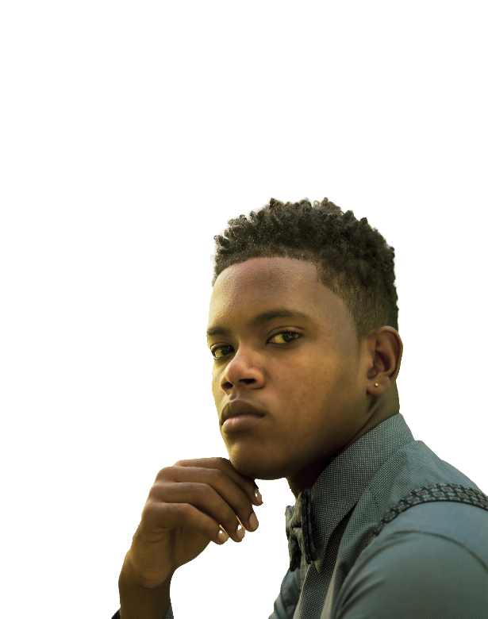

Derice McKenzie
Chairperson, Publications Committee, FSTGC

Life is just a bunch of experiences bungled up into one big thing, so don’t be afraid to step out into new territory and expand your horizons. Experience and enjoy yuh life!! The road ahead is going to be hard, and you might feel like yuh cyah badda somewhere along the way, but never lose hope. It is always the darkest near dawn so push thru and believe in yourself because yuh great an yaah star.

Rumaine Watson
Biochemistry Section Student Representative, FSTGC

“Igniting the passion, keeping the flame”
The 2021-2022 academic year will entail informative interactions among the students as it is geared on acquiring the knowledge needed for future references for those within the Biochemistry Section. Specifically, giving students more understanding of their capabilities, responsibilities, and power they hold as students and citizens within the Biochemistry section

Yashique White
Department of Chemistry Student Representative, FSTGC

Tears, sweat and sleep is what I am willing to sacrifice to accomplish my goals. With my highly optimistic personality I will not stop aiming to be the best in what I do. I have had many encounters with different persons from different backgrounds, all having different perspectives, but I am not a close - minded person. As such, I make it my duty to learn what I can from these people to help them solve their problems thereby making my environment a happier one. Quote: “Dreams lead to goals and goals backed up with productive actions lead to reality” ~ Yashique White

Tariq Kelly
Department of Computing Student Representative, FSTGC

I would describe myself as a very atypical student leader, I proudly display my flaws, my tendency to procrastinate and I say what’s on my mind in any environment but despite these flaws I try to lead with creativity, empathy and innovation. I’m always looking for new and interesting experiences and I intend for this to be one of them. My plan for this position is to make being in the Department of Computing something to be proud of as we all bond through the struggle. “The future belongs to those who believe in the beauty of their dreams.” ― Eleanor Roosevelt

Nyckalia Prendergast
Department of Geography and Geology Student Representative, FSTGC

It is truly a blessing to serve the Faculty of Greatness and a department of promising students with whom I have their best interest at heart. As an overachiever, I consistently perform optimally, and this opportunity is no different. I have plans as vast as the ocean, goals that graze the stars and hope that could easily encompass the universe. For my tenure, I want to promote integration within my department and nurture a close knitted bond between students and staff that will endure for years. I want to instill hope in light of the pandemic to encourage students to keep persevering until they succeed. Marianne Williamson said it best, “Our deepest fear is not that we are inadequate. Our deepest fear is that we are powerful beyond measure.”

Britney Richards
Department of Life Sciences Student Representative, FSTGC

I am a kind, genuine, and selfless individual, who seeks to help others when in need even when it comes in the way of my priorities. With these attributes, I tend to serve the Department of Life Sciences and the entire FST family throughout my tenure as the Life Sciences Representative for the academic year 2021/22 and beyond. Throughout my tenure, I would like for most of the students in the Department Life Sciences to have a 100% pass in their courses and to create connections and memories that will last a lifetime. My Message to the Department of Life Sciences and to the entire FST family: “Interact with other students and lecturers! Have a positive mindset! Have faith! Be a multitasker! Practice proper time management! Keep up to date with classes! Care for others! and You’ll Be All Set!!!” ~Britney Richards.

Othandrea Downes
Department of Mathematics Student Representative, FSTGC

When there are no enemies within, the enemies outside can do us no harm. Every organization, entity, corporation, or department has a goal to fulfil. The great Henry Ford encouragingly said, “Coming together is a beginning, staying together is a process and working together is success”. In my tenure as the Mathematics Department Representative, I intend to engender and facilitate proper communication while constructing a more inclusive department where students from other campuses can join in the fun and excitement. My aim is to ensure that the department is more student focused by offering more student involvement opportunities for greater socialization and networking especially since the current online modality limits our ability to interact.

Orane Green
Department of Physics Student Representative, FSTGC

As I reprise my role, 2nd tenure will be geared towards creating a legacy of art, community, and academic success. This shall be accomplished by strengthening the Physics Resources drive to ensure students’ success, regionalizing the Atomic Splash Talent Show & JamSPARC to continuously provide a creative outlet and a network of opportunities.

