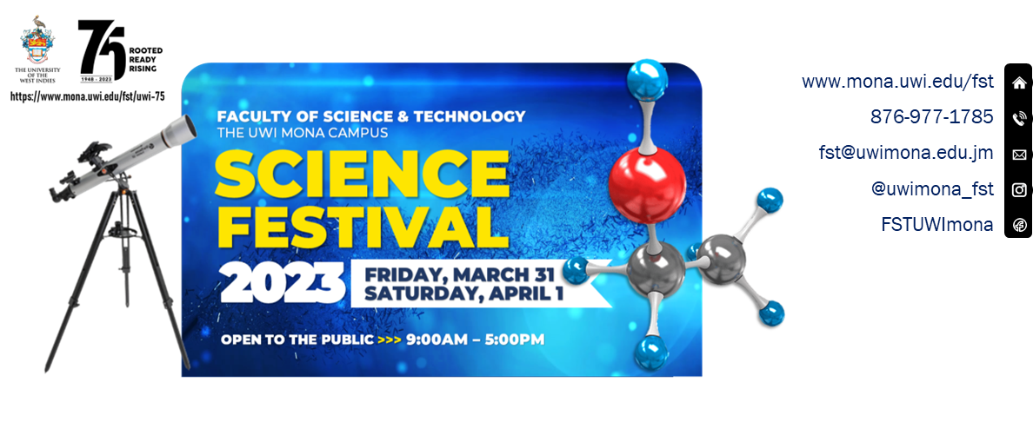

Dear Partners:

Thank you for agreeing to participate as an exhibitor in The UWI Science Festival to be held Friday March 31 to Saturday April 1, 2023. The following are some logistics to be mindful of:

- Offloading: The offloading areas for exhibit items will be the Chemistry Parking Lot and the Physics Parking Lot. These areas will only provide parking to accommodate offloading and then exhibitors will be directed to one of the other parking areas on Campus.

- Information Desk: Information Desks will be set up at the entrances to the Chemistry and Physics Departments to assist in directing exhibitors to their booths.

- Festival Directory: A draft Festival Directory is available on page 3.

- Setting up exhibit - Day before event: Some exhibitors have indicated an interest in setting up on March 30 from 1:00 p.m. Although security personnel will be available, we encourage you not to leave valuable large equipment at the exhibition site unless necessary and this is indicated to The UWI Team explicitly in advance. The exhibit areas are expansive and therefore 24-hour security coverage of all areas will not be possible. However should you require storage, a storage area can be provided.

- Setting up exhibit - On the day: We encourage exhibitors who will set up on the days of the festival to arrive by at least 6:45 a.m. to enable completion of set up before 9:00 a.m. – our scheduled start time.

- Best Booth Competition: We will invite attendees to vote for the Best Booth on each day. We encourage exhibitors to make your booths as interactive and innovative as possible, showcasing the science at work in your activities.

- Launch Ceremony: We will host a launch ceremony on Friday March 31 at 9:30 a.m. Thereafter a delegation of specially invited guests will conduct a tour of the exhibits. Schools and other visitors will commence viewing at 9:00 a.m. (and perhaps before).

- Marketing content: We may have central display boards for sharing festival and marketing content. If you wish to share marketing content with us please provide a high resolution video no longer than 7s. Please send this file to uwimonasciencefestival@gmail.com.
In this email, also consider sharing:
- Your logo; and a short (1-2 sentences only) blurb on your company.
These may be included in a festival guide that will be available to participants online. We encourage exhibitors to share the requested content no later than Friday March 24.

- Technical Assistance: To provide support to exhibitors on the days of the festival, the following liaisons will be available to assist. Please feel free to call or to visit the information desk for assistance.
- Mrs. Nadine McEwan – 876-475-4715
- Mr. Maxwell Williams – 876-350-5128

- Health Emergency: In the event of a health emergency, medical assistance can be accessed via an ambulance service situated in the Physics Parking Lot. Please call 876-851-7600 if assistance is required.

- Security: In the event security personnel is required, please call 876-551-0134 (Mona Campus Patrol). We will also have security patrols at the festival.

- Lunch: Several kiosks and food stalls across campus provide quick meals to go. Options include fruits, wraps, hot dogs, sandwiches, salads and hot meals.
- The Bee Hive Kiosk (Located at the Faculty of Humanities and Education)
- Boardwalk Cafe (Located at the Faculty of Social Sciences)
- Nardo’s Food Stall (Located at the Faculty of Humanities and Education)
- The Spot Sports Bar and Grill (Located at the Students’ Union)
- Campus Café (Located at The University Hospital of the West Indies (UHWI))
- K&S Snack Kiosk (Located in vicinity of the Science and Engineering Branch Library)
- Lawrence & Jackie’s Kiosk (Located in vicinity of the Science and Engineering Branch Library)
- Burger King (Close proximity to Faculty of Law, Mona School of Business and Management) Faculty of Medial Sciences)
- KFC (Close Proximity to Taylor Hall, Chancellor Hall, Main Library)
- Juici Patties (Close Proximity to the Festival areas)

- Disassembling exhibits: Exhibitors are invited to disassemble exhibits after 5:30 p.m. on your final day of participation. We encourage you to ensure that all exhibit items belonging to your institutions are removed.

Thank you once again for your support of The UWI Science Festival – 75th Anniversary Edition. We look forward to two days of science and fun.

FESTIVAL DIRECTORY
The Tech and Analytics Hub [BLOCK B / NEXT TO COMPUTING]
- Global Anunaki Tech Enterprise Limited | - StarApple Analytics** | - Mona Geoinformatics Institute (F)
- Jamaica Technology and Digital Alliance (JTDA)
The SciTech Agencies [LAWNS ACROSS FROM LIBRARY]
- Scientific Research Council (F)** | - National Irrigation Commission (F) | - Meteorological Service Jamaica
- Island Traffic Authority | - Jamaica Constabulary Force | - National Certification Body of Jamaica
- National Fisheries Authority
The Business Centre [PHYSICS QUADRANGLE]
- Transactions E-Pins Limited | - Bartley’s All in Wood (F) | - Mighty Spice Jamaica Limited
- Sun Plus Limited | - Conrad Douglas and Associates Limited** | - Guardsman Group (F)**
- Consolidated Environment Research Laboratory (CERES LABS) | - PKay Jewellery | - Caribbean Climate Innovation Centre**
- Renewable Energy Design and Installation Services Limited
The Health and Wellness Club [IN FRONT OF FACULTY OFFICE]
- Taynas Body Care | - JamKin Juice** | - Eden Joy Whole Foods (F)
- Smart Choice Solutions Limited (S)**
UNESCO Education Village [ENGINEERING LAWNS / LAWNS ADJACENT TO SLT3 ]
- STEM Builders Learning Hub | - UWI: Science and Engineering Branch Library | - UWI: Marketing and Communications
- UWI: Office of Graduate Studies and Research | - UWI: Mona Social Services
The FST Sci-Texperience [SPINE]
- Chemistry | - Computing | - Geography and Geology
- Life Sciences  (including Port Royal Marine Lab) | - Mathematics | - Physics
- ICENS | - Earthquake Unit** | - The Biotechnology Centre
Student Entrepreneurs Exhibit (SEE) – IN FRONT OF C6/C7
- Valtaz Jamaica (F) | - JAOS Shipping Services | - Neik
- Tae’s Enterprise | - Genesis Career Centre | - Nashaccessories
- Exceptions Beauty
Staff Trade & Entrepreneurial Platform (STEP) – NEAR GUILD OFFICE
- Radiant Skaii | - Rose-Ann Smith | - Estrella de Mar Inc.

** Set up on March 30 at 1:00 p.m.
(F) – Friday only Participation
(S) – Saturday only Participation

